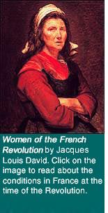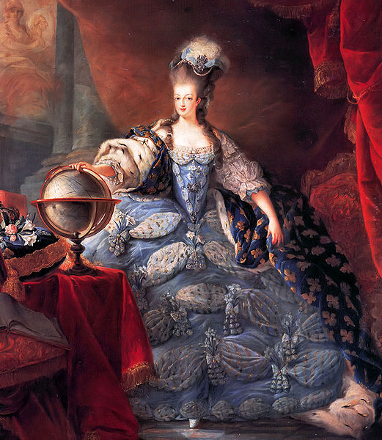
Two different views of the Revolution. The gap between the rich and the poor was very evident. Is that still evident today? Is this gap a problem? What visual connections can you think of to express that gap today? On the back of this paper write a brief overview of how the French Revolution background conditions are similar to America’s woes today.

